Proffessor: Robert Sandor
Student: Omer incialan
Summer 2023 - Foothill College
SERVERLESS DATA PROCESSING (WILDRYDES)

Table of Contents
1- Kinesis Wildrydes kinesis Data stream creation 2
2- Metrics showing monitoring of running Wildrydes Data stream 3
3- Cloud9 IDE showing a running producer window 4
4- Cloud9 IDE showing the consumer data stream (actually showing the JSON data of monitored events) 4
5- Cognito showing Identity Pool ID 5
6- Dashboard showing the single unicorn status on the Dashboard 5
7- Dashboard showing multiple unicorn status on the Dashboard 6
8- DynamoDB table definition including table name, partition key, sort key, etc. 6
9- SQS queuing service queue configuration. 7
10- IAM role for the Lambda function. 7
11- IAM WildRydesStreamProcessorRole: 8
12- Lambda function to process the stream 8
a. Include the source code listing 8
b. Show the Environment variables set. 9
c. Show the deployed trigger. 9
13- Successful Lambda processing 10
a. Verify the Lambda execution and show the CloudWatch logs when producing streaming data. 10
b. Show the DynamoDB table for the Shadowfax unicorn showing the records placed in the table. 11
14- Error handling 12
a. Show the CloudWatch logs of the Lambda function processing the errors and the SQS messages 12
i. Error Handling with Retry Settings 12
b. Error Handling with Bisect On Batch settings 12
i. If you can, show the new DynamoDB records recorded 12
15- Analytics with Tumbling Windows 14
16- Stream aggregation 15
a. Show the consumer window of the Cloud 9 IDE showing both Shadowfax and Bucephalus unicorn sensor reports. 16
17- Data Lake 16
a. Show the Athena query of SELECT * FROM wildrydes_athena result. 16
18- Clean Up 19

Kinesis Wildrydes kinesis Data stream creation
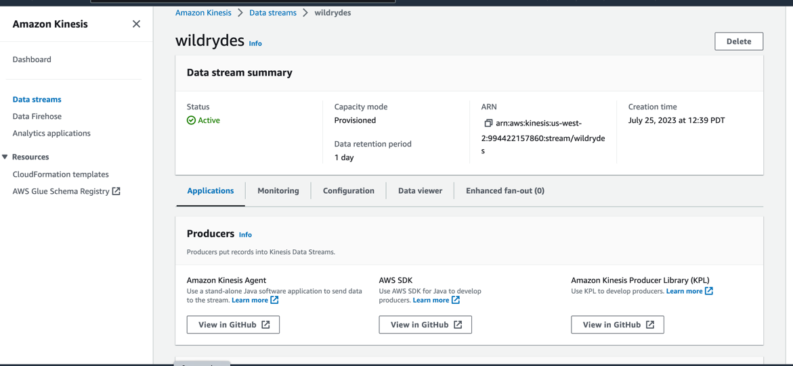

Metrics showing monitoring of running Wildrydes Data stream
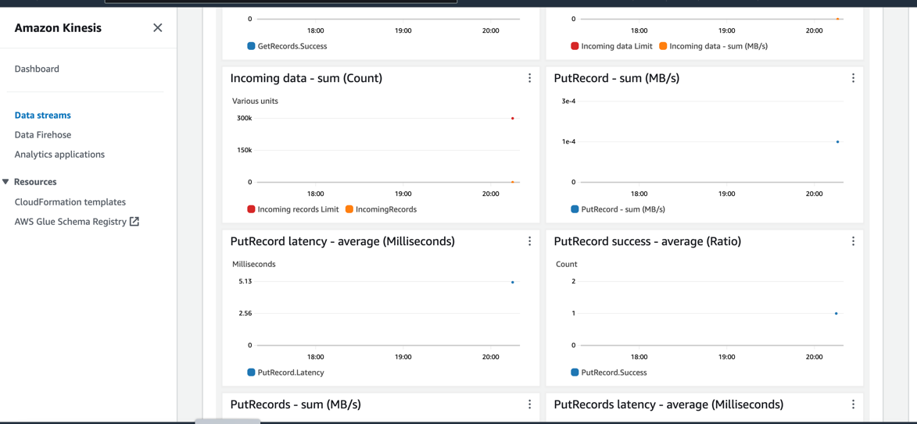

Cloud9 IDE showing a running producer window
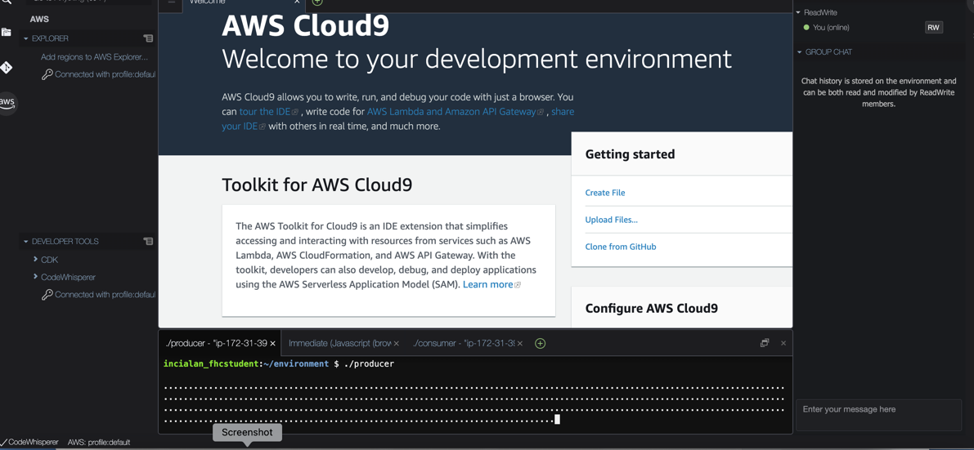

Cloud9 IDE showing the consumer data stream (actually showing the JSON data of monitored events)
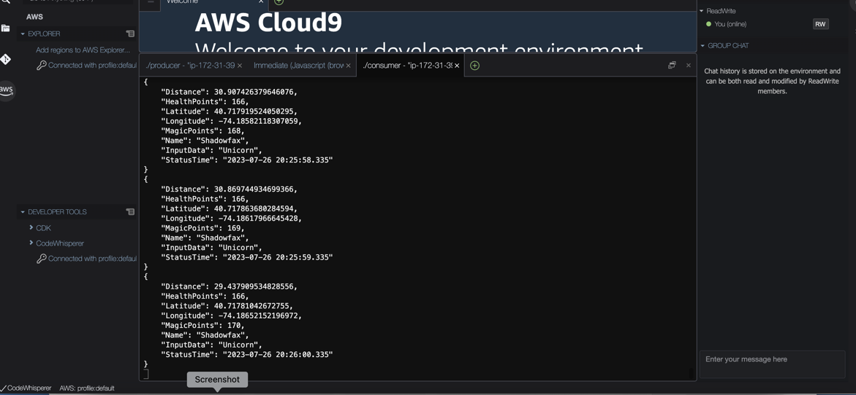

Cognito showing Identity Pool ID
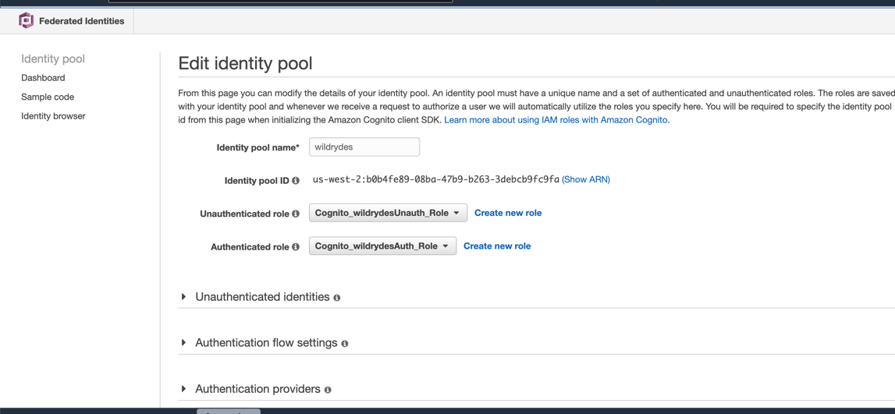

Dashboard showing the single unicorn status on the Dashboard
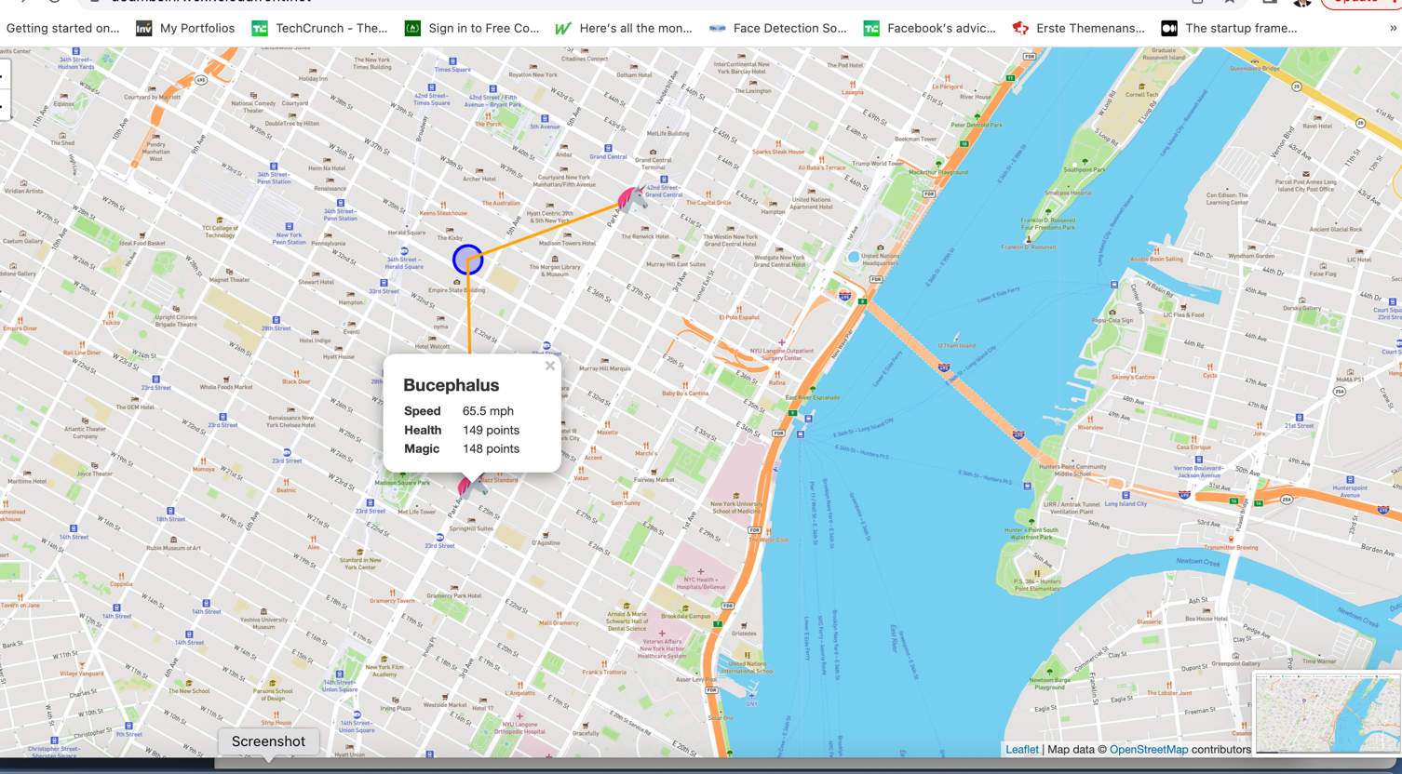

Dashboard showing multiple unicorn status on the Dashboard
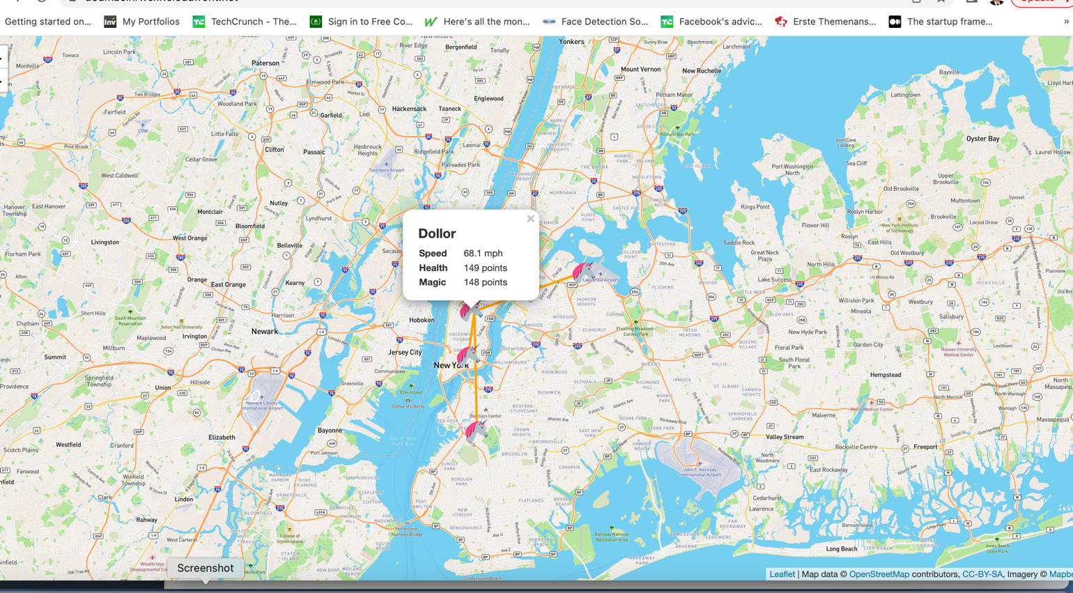

DynamoDB table definition including table name, partition key, sort key, etc.
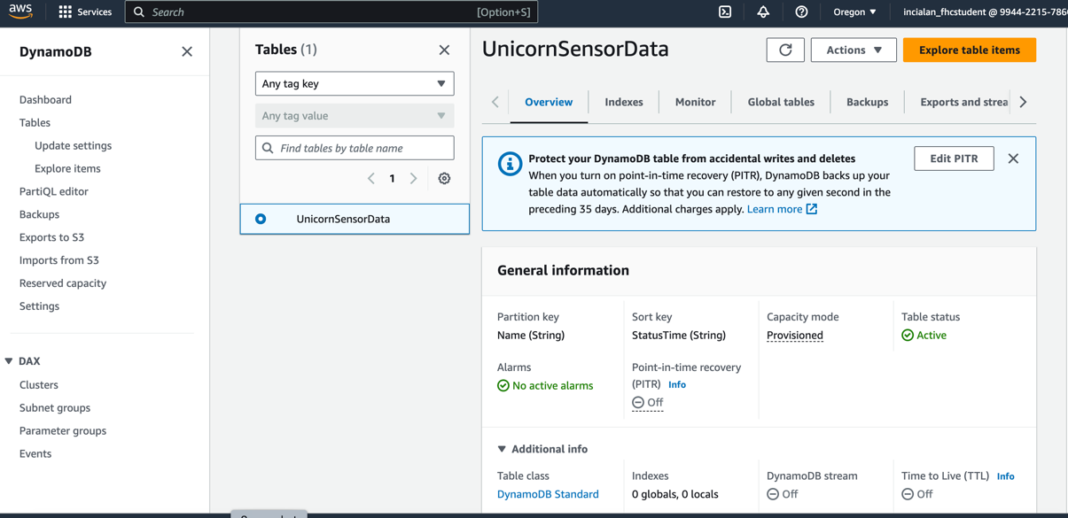

SQS queuing service queue configuration.
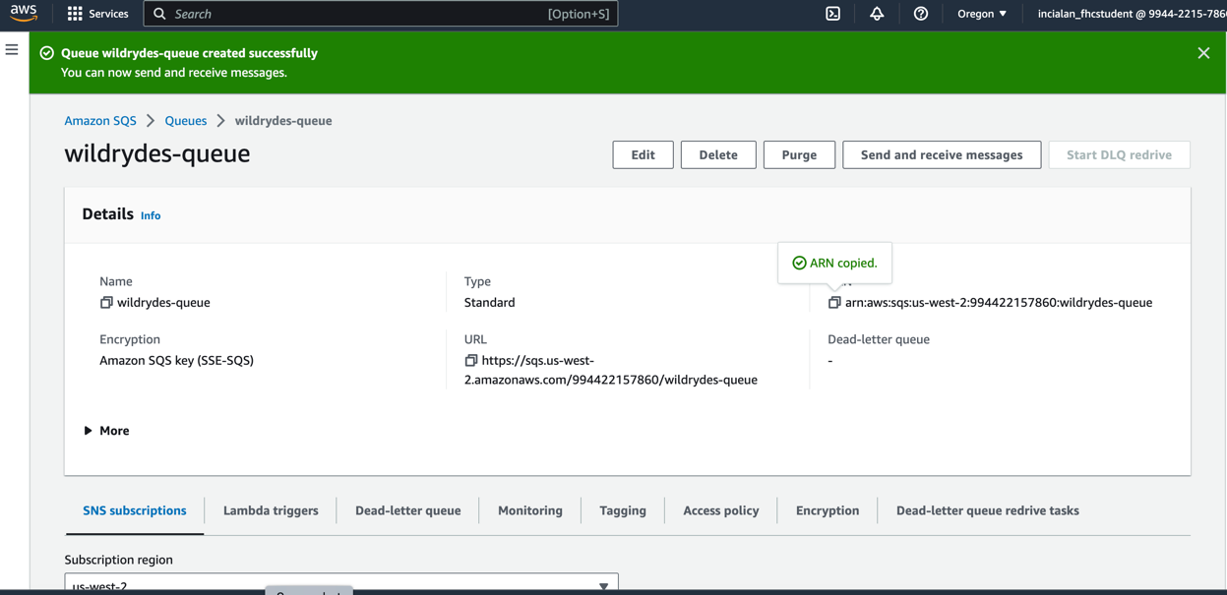

IAM role for the Lambda function.
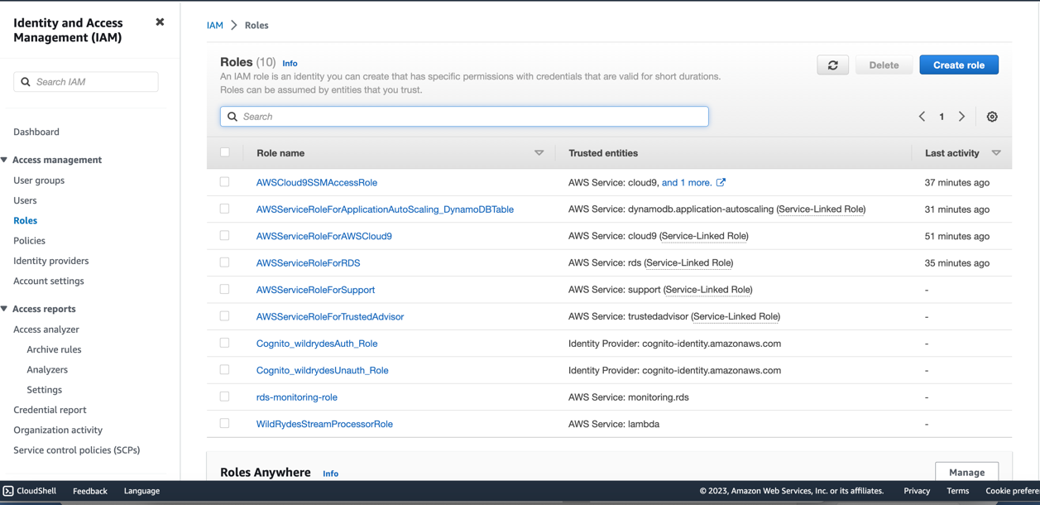

IAM WildRydesStreamProcessorRole:
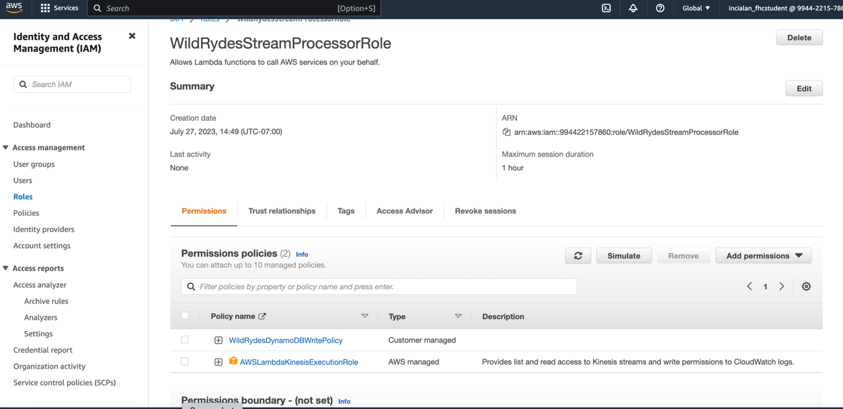

Lambda function to process the stream

Include the source code listing
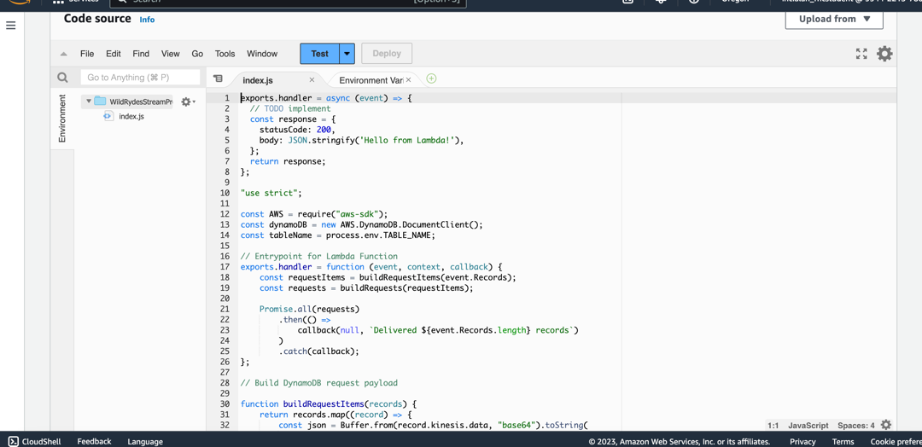

Show the Environment variables set.

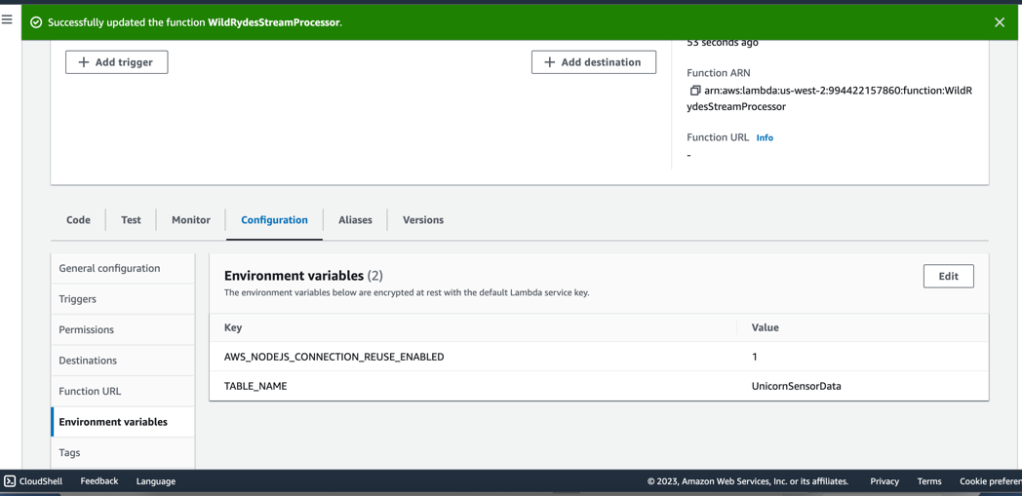

Show the deployed trigger.
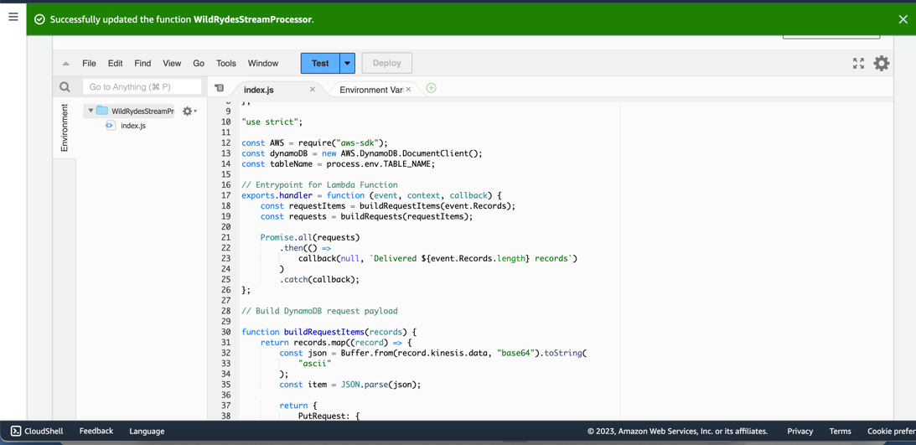

Successful Lambda processing

Verify the Lambda execution and show the CloudWatch logs when producing streaming data.
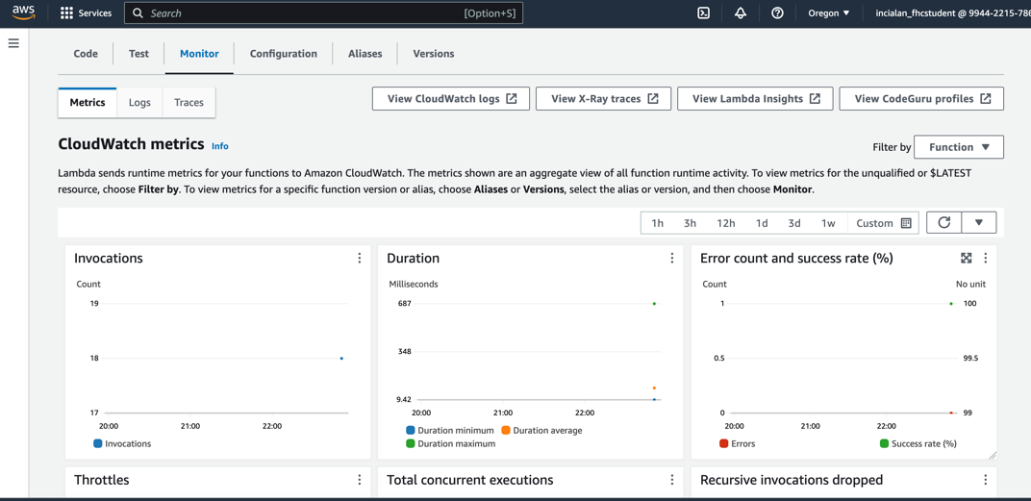

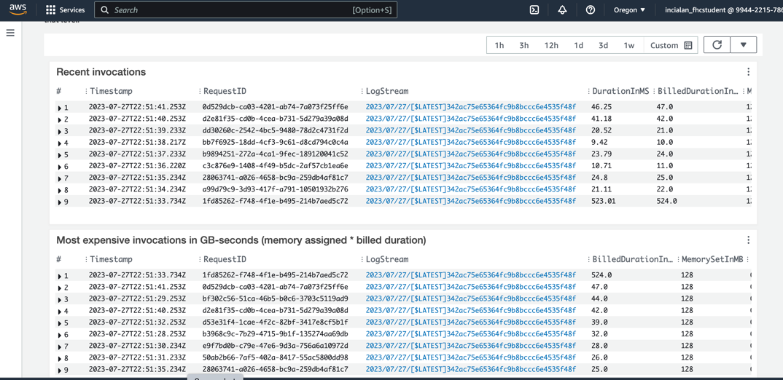

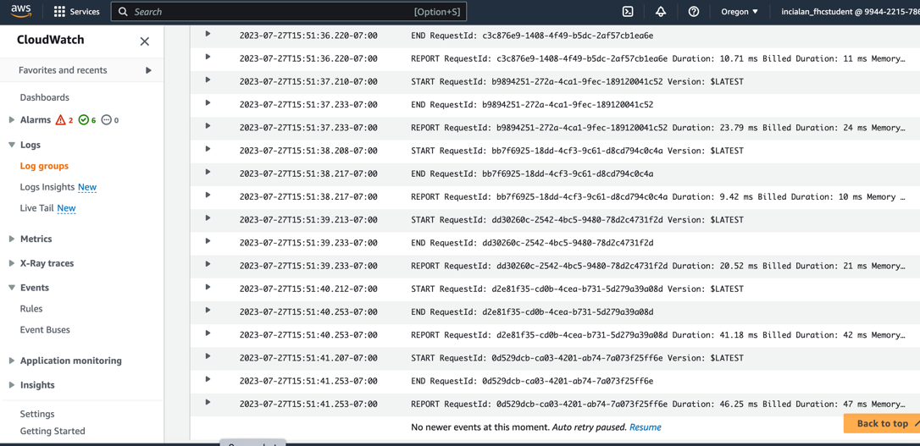

Show the DynamoDB table for the Shadowfax unicorn showing the records placed in the table.
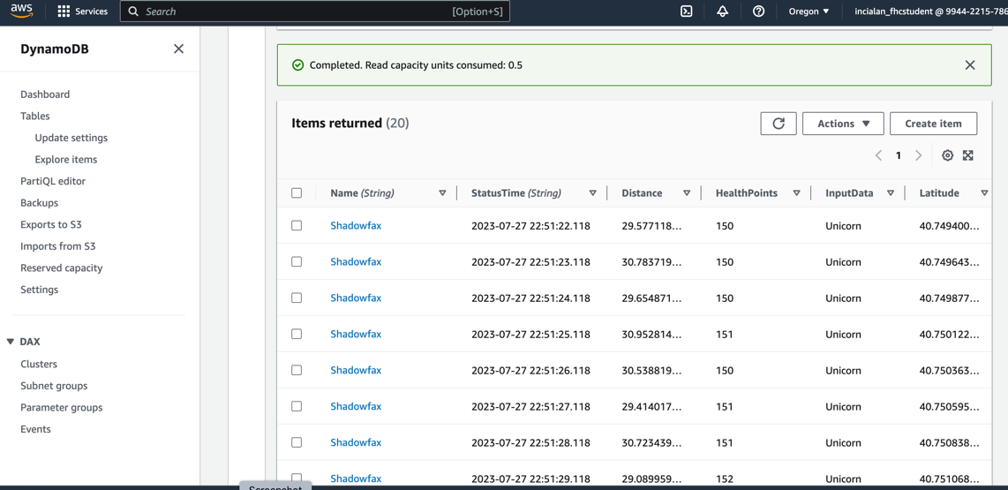

Error handling

Show the CloudWatch logs of the Lambda function processing the errors and the SQS messages

Error Handling with Retry Settings
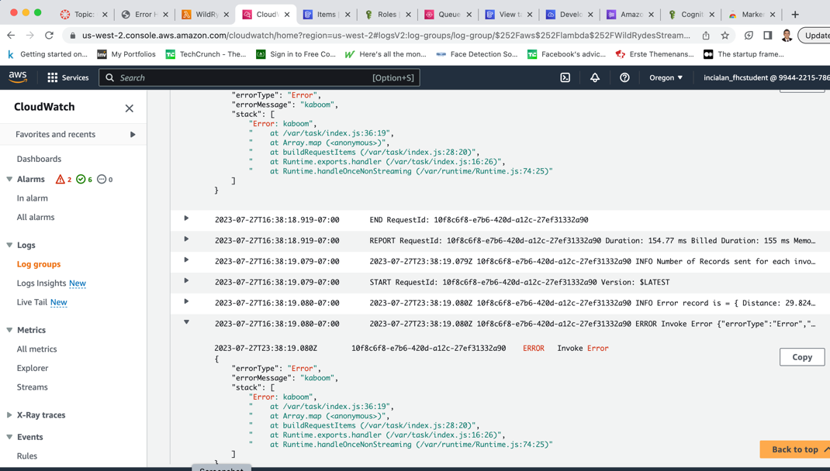

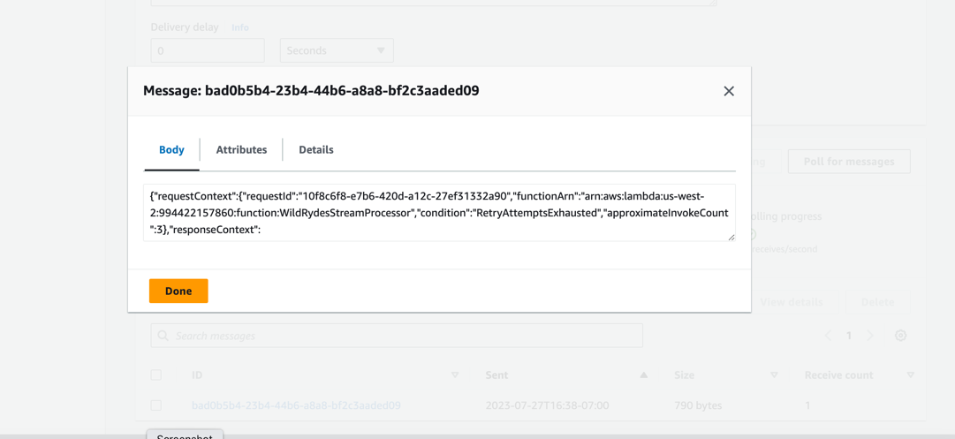

Error Handling with Bisect On Batch settings

The new DynamoDB records recorded
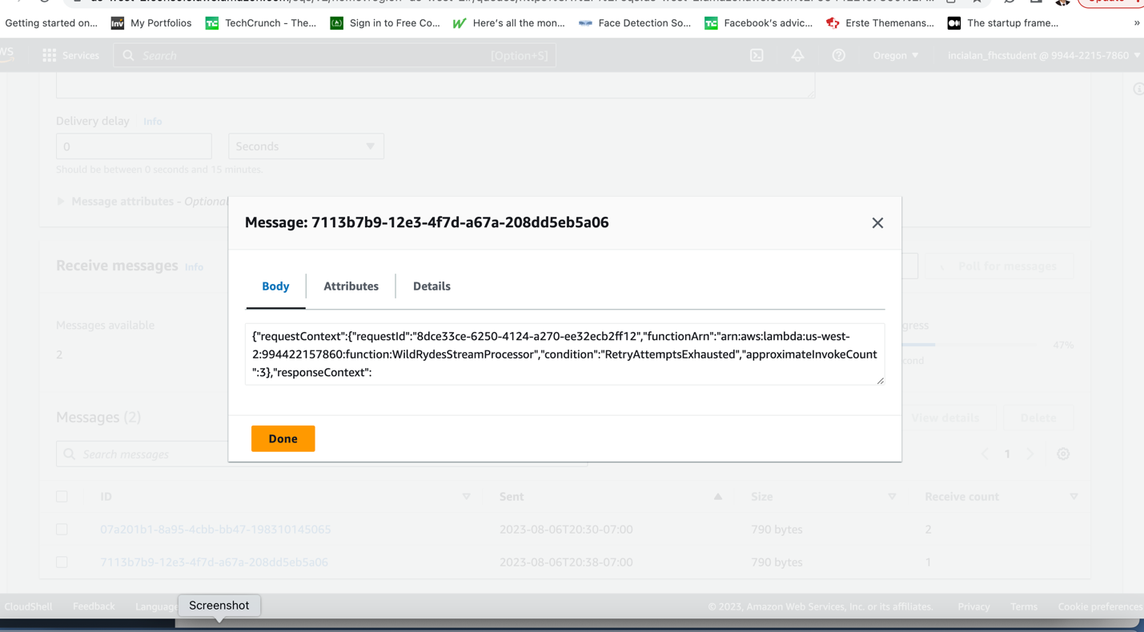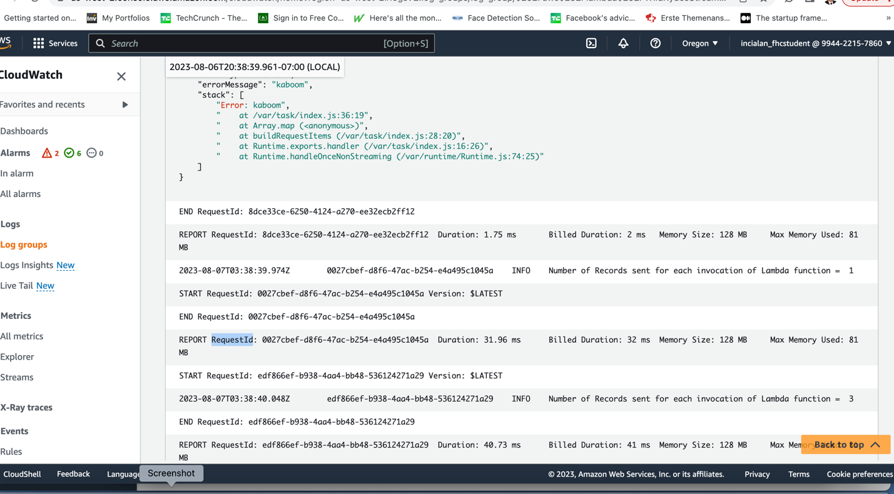

Analytics with Tumbling Windows

DynamoDB UnicornAggreation table

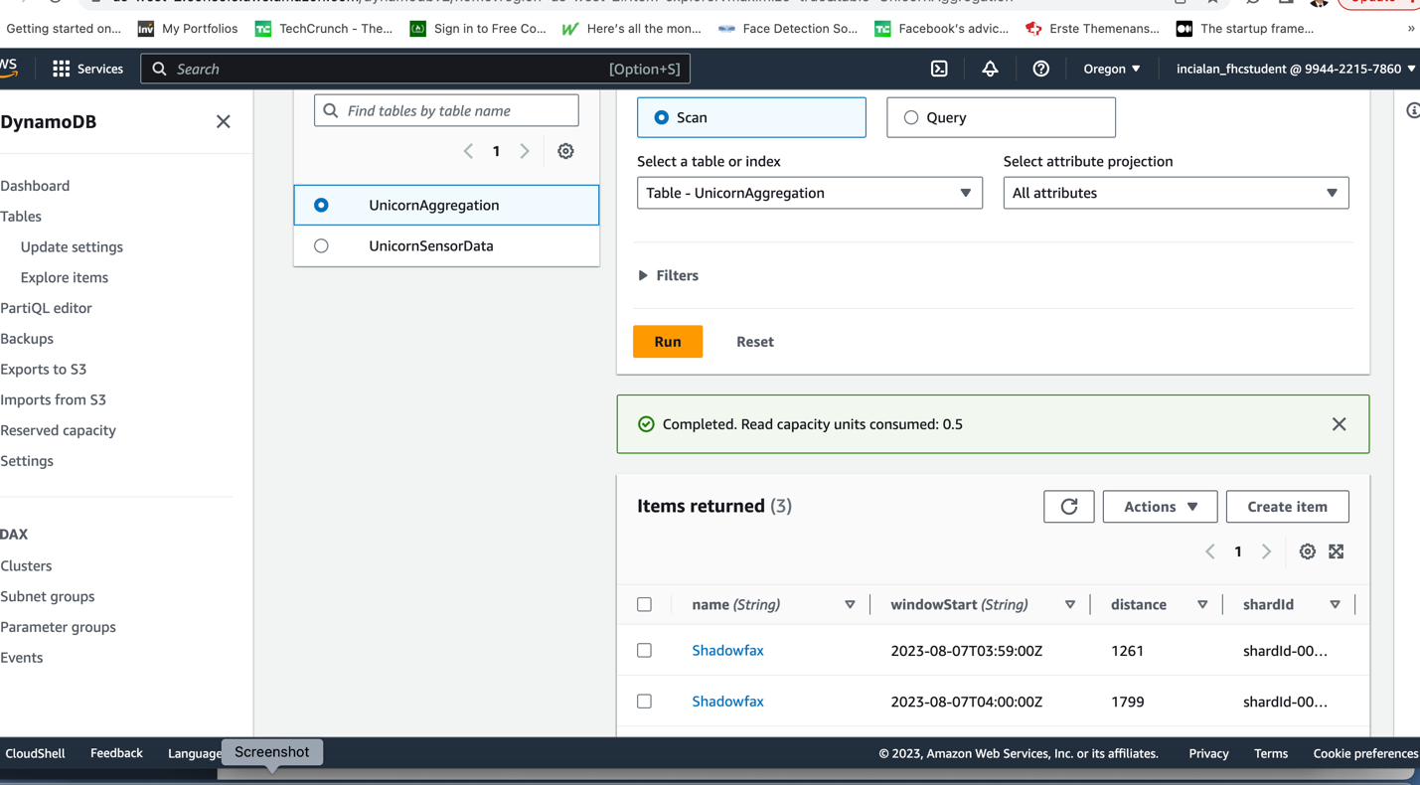

Create a DynamoDB table
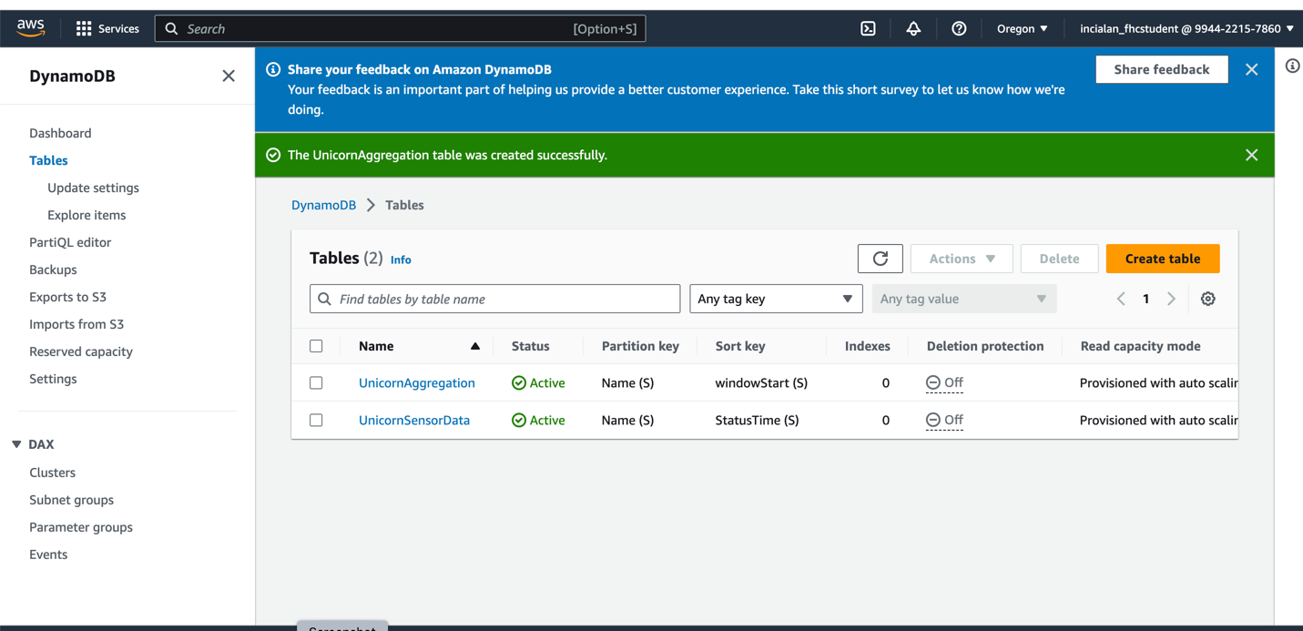
Create an IAM Role
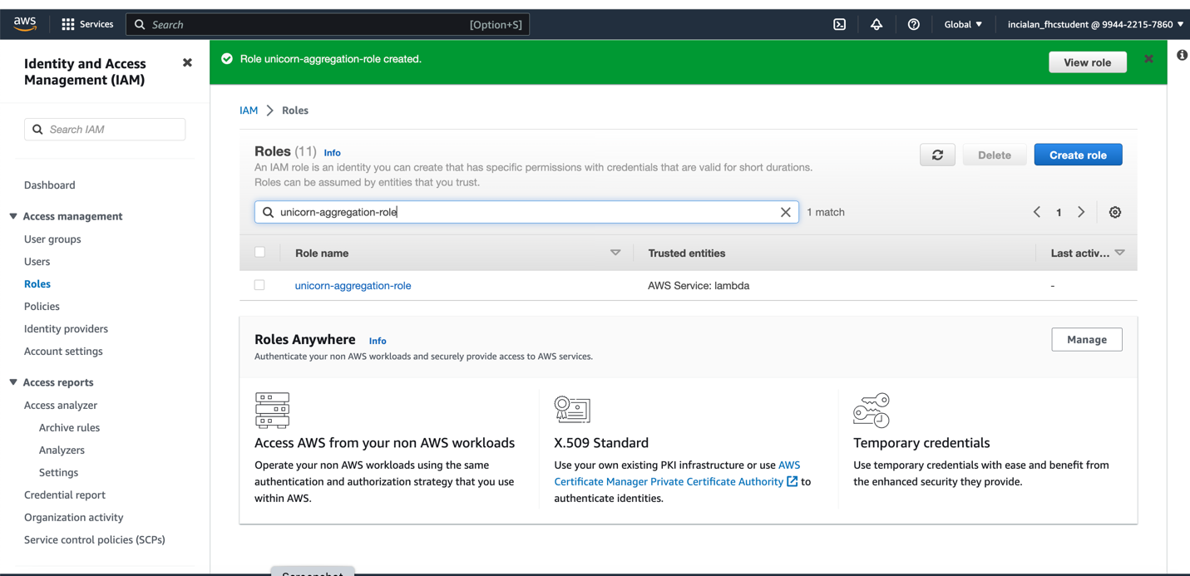

Create a Lambda function
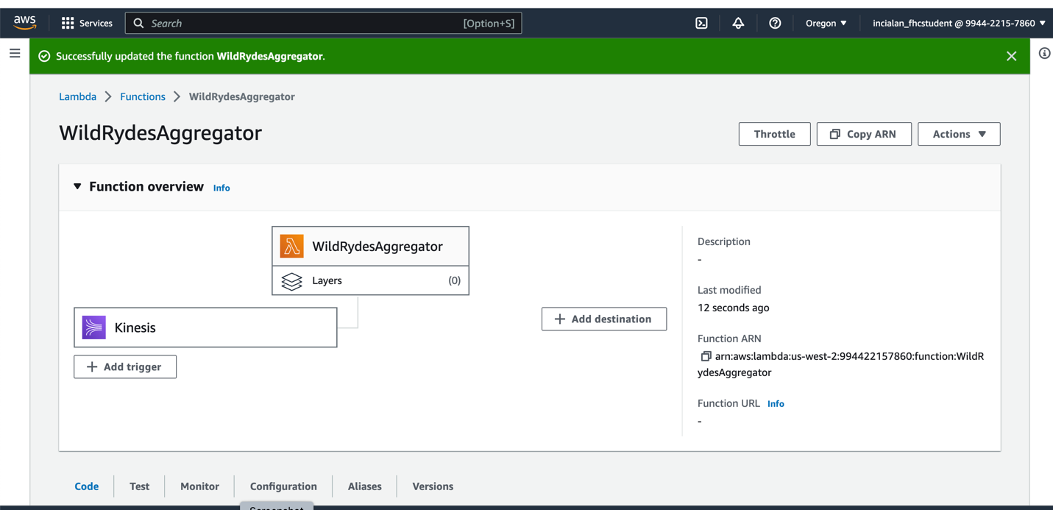
Monitor the Lambda function
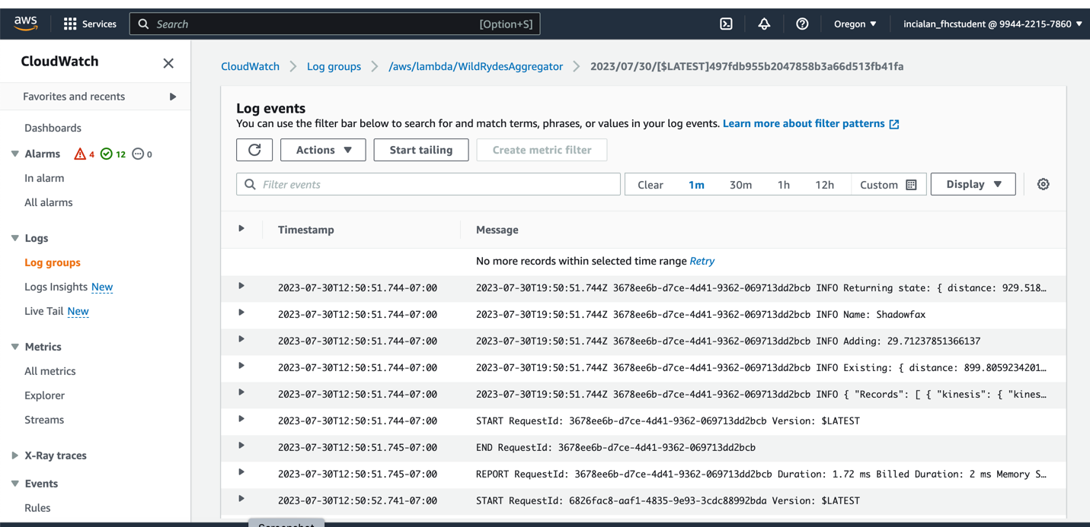

Stream aggregation

Show the consumer window of the Cloud 9 IDE showing both Shadowfax and Bucephalus unicorn sensor reports.

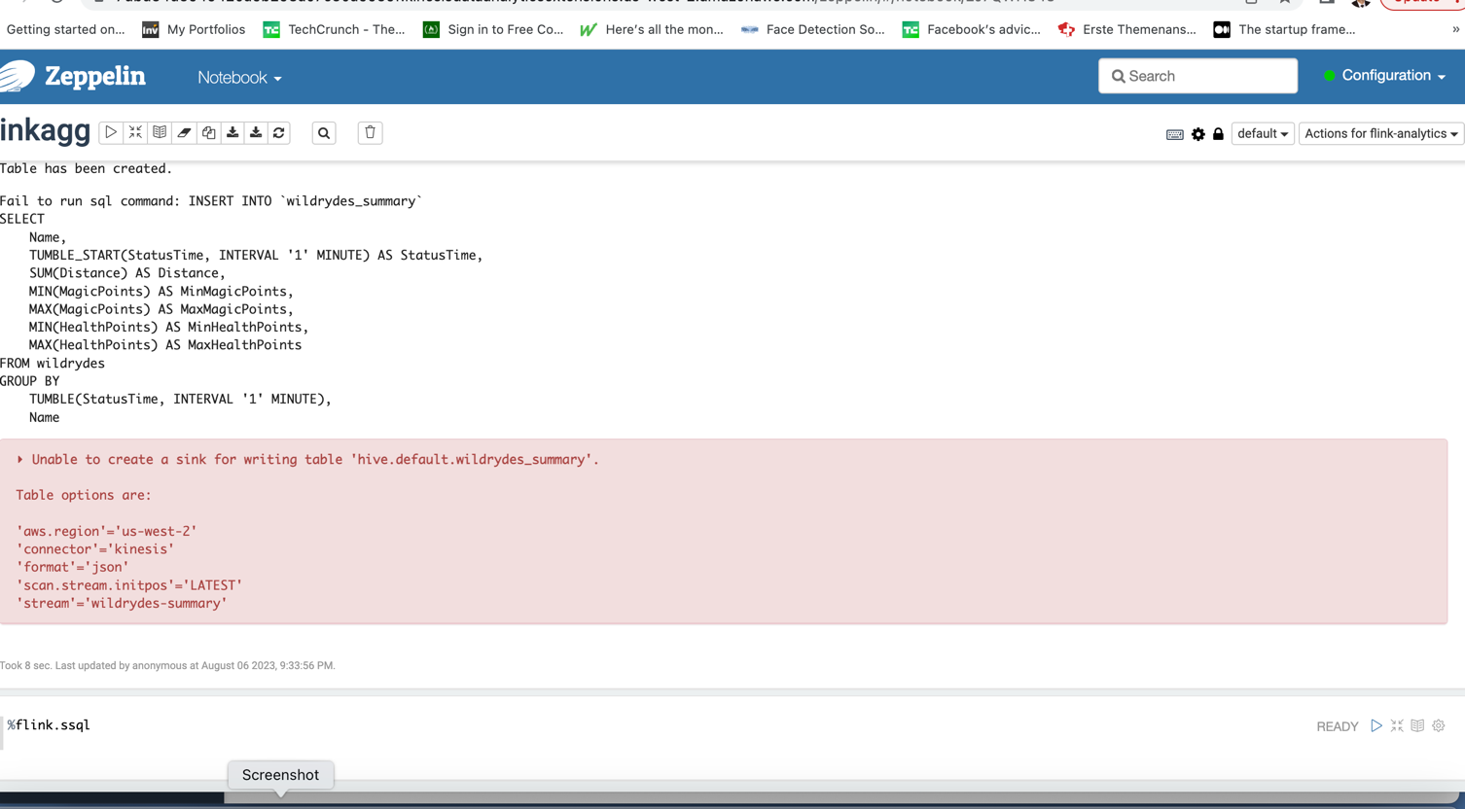

Here, we tried to create a summary environment to analyze streaming data every minute. However due to an error on Flink connection, we cannot create an environment for streaming data to be analyzed every minute.

Data Lake

Show the Athena query of SELECT * FROM wildrydes_athena result.
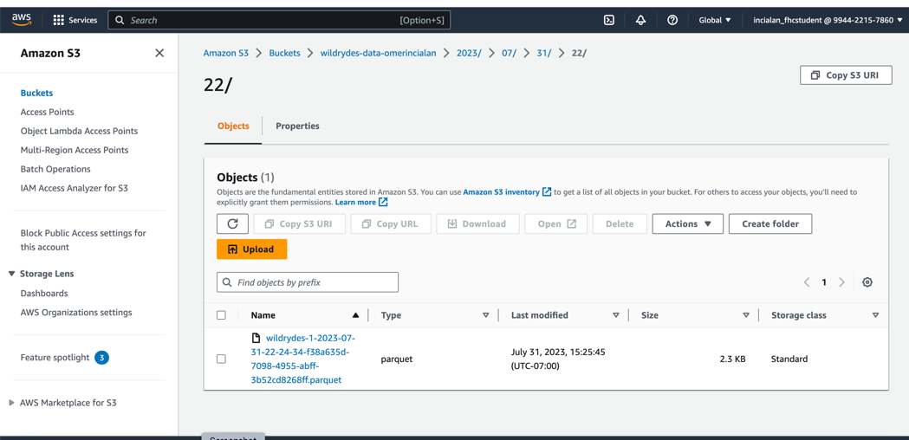
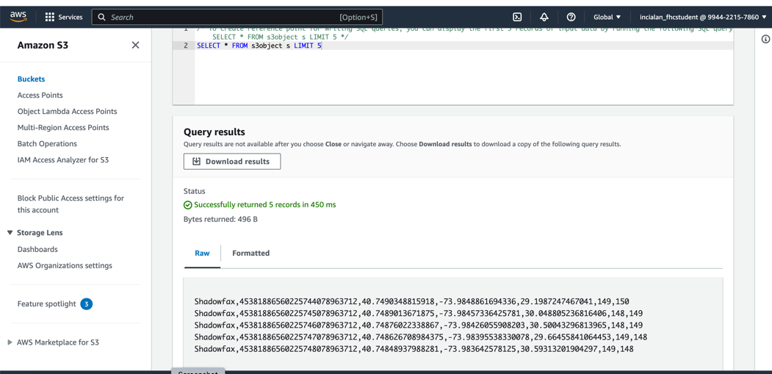

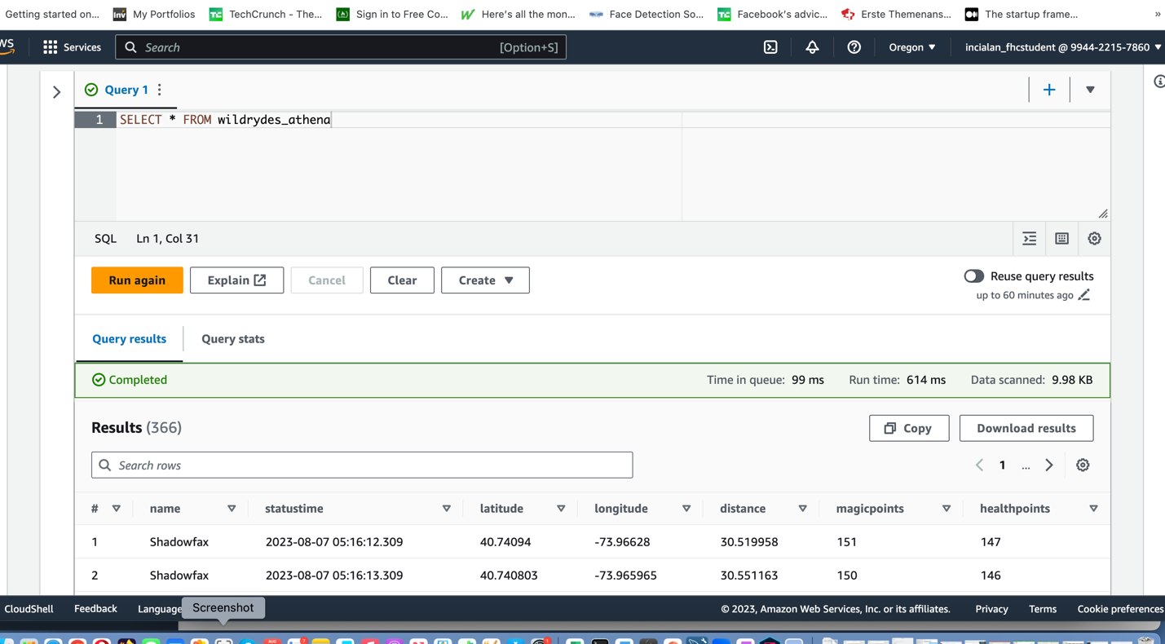

Clean Up
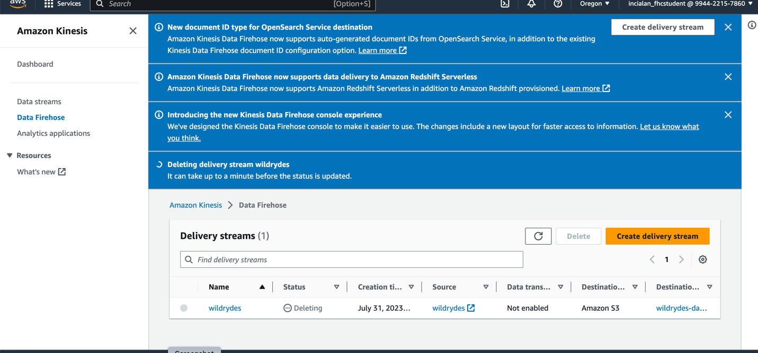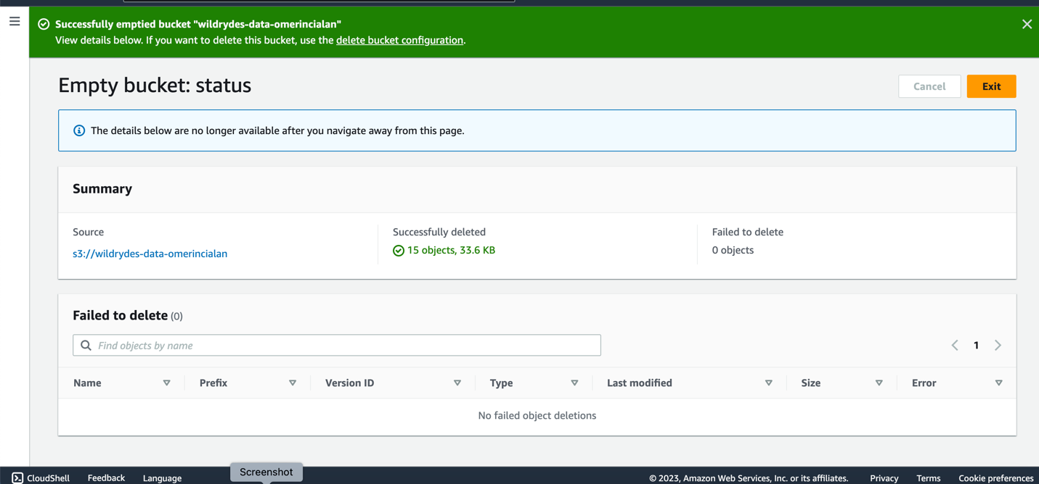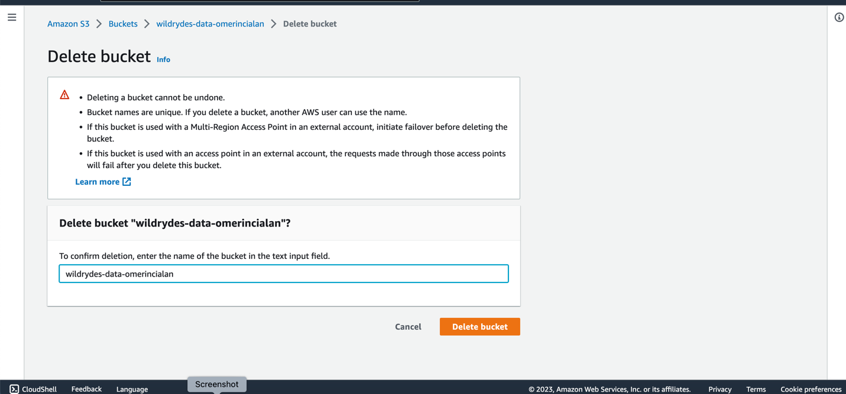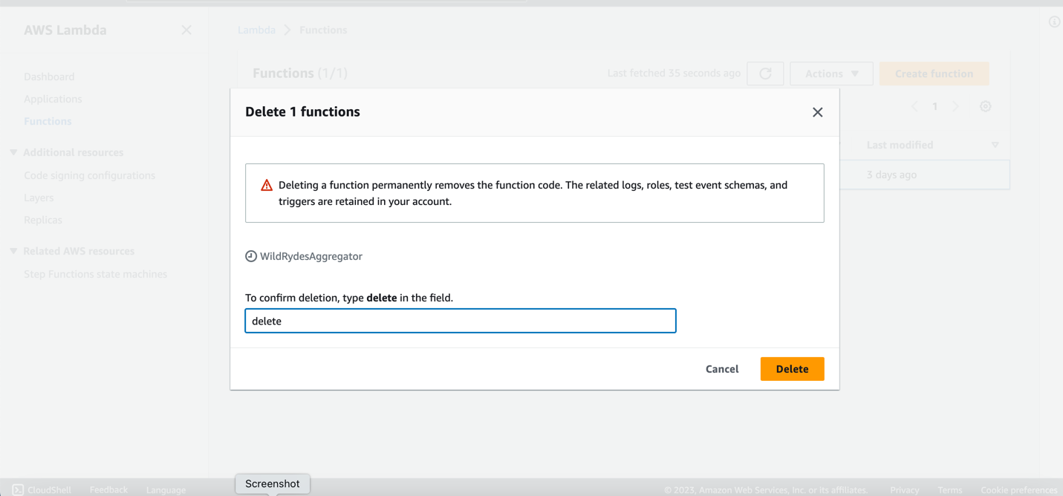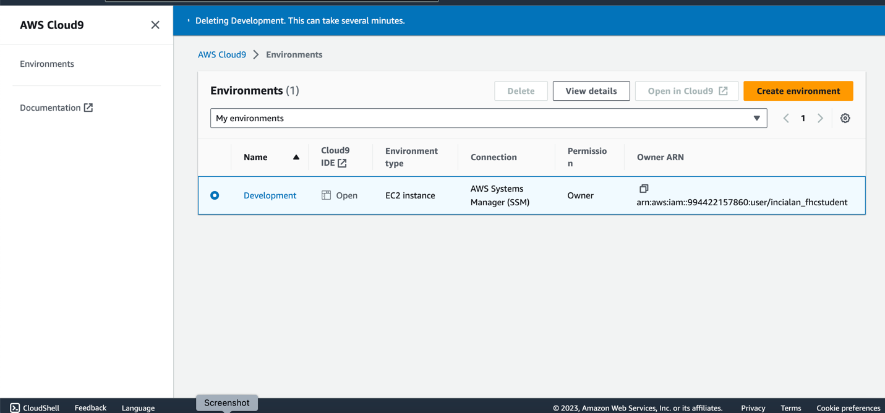

Real Time Data Streaming
In this module, I created an Amazon Kinesis stream to collect and store sensor data from our unicorn fleet. Unicorns (as producers) emits data to Kinesis, and as a consumer the role I created accesses to Unicorn Dasboard to monitor Unicorns’ location, health etc.
I used IAM service of AWS to authenticate user access to stream.

Stream Processine and Analytics with AWS Lambda
In this module, we started to add more functionality to project by building a Lambda Function the stream. As data arrives from unicorns to stream, based on specific parameters we set, Lambda Function triggers some actions to be performed such as sending failed queries to a separate place (SQS Queue) and storing write arriving records to a DynameDB table.

As an error handling method we first used retry settings and then bisect on batch method. While first method discards entire table even if there is only one failed record second one splits the batch into half and process each half separately until only one failed records remains.

Stream Aggregation
Here, I tried to build an analysis layer to the streaming data by using Amazon Kinesis Data Analytics Application. By specifying certain calculations, I could have instant insight from the field. To be able to function properly , I Used AWS Glue and IAM to authenticate users on specific analytics tasks.
My goal was to analyze streaming data of Unicorns every 60 seconds and send the output as a summary row to another analytics environment (DynamoDB)

Data Lake
In this module, I used S3 service of AWS to store my raw data. I also, ran queries on the raw data my unicorns produced at the first module.
I used Kinesis Data Firehose delivery stream to pull data from my stream.
I used Amazon Athena to query my raw data. To improve my query permance my raw data was transformed into Apache Parquet format, by using Amazon Athena I can access to previously transformed data.

As I watch education videos about AWS, I realize that you can do almost anything you need by using AWS services. For example by analyzing travel distance of unicorns in a specific time interval, we can know if they violate speed limits. By tracking their health data, we can offer them timely breaks.

